CONTEÚDO PROGRAMÁTICO 2 - ATIVIDADES

Utilizando as técnicas de skimming e scanning que você já conhece, responda as questões sobre os textos abaixo.

Remote Work Wins

The hit new video game Spider-Man 2 is set in a bustling re-creation of New York City, complete with digital versions of busy workers commuting to their offices. But many of the people who made the game were able to live out a different experience — working from their homes full-time.
“While we generally believe onsite collaboration to be most efficient, if your type of work allows it, and your direct supervisor agrees, you can opt in to work remotely,” said a CD Projekt Red spokesperson.

Fonte: https://www.bloomberg.com/news/newsletters/2023-10-27/some-of-this-year-s-biggest-video-games-were-made-from-home?srnd=technology-vp

1. Sobre o texto acima, qual o principal assunto abordado?

R: Fala sobre o trabalho remoto (home office) e cita como ex. o jogo spider-man 2.

2. Ainda sobre o texto acima, quais as principais palavras que te ajudaram na compreensão?

R: Office(escritório), efficient(eficiente), collaboration(colaboração), video game, full-time(Tempo integral)

Error message

This is the mail system at host mx.uol.com.br.
I am sorry to inform you that your message could not be delivered to one or more recipients. It is attached below.
For further assistance, please send mail to postmaster.

3. No texto acima, negrite ou sublime o verbo to be em suas variações.

4. Escreva as palavras que você conhece deste texto e sua tradução.

R: system(Sistema), mail(e-mail), sorry(desculpe), message(mensagem), delivered(entregue)

What is the internet of things (IoT)?

The internet of things, or IoT, is a network of interrelated devices that connect and interchange data with other IoT devices and the cloud. IoT devices are typically embedded with technology such as sensors and software and can include mechanical and digital machines and consumer objects.
Organizations in a variety of industries are using IoT to operate more efficiently.
With IoT, data is transferable over a network without human-to-human or human-to computer interactions. It may be a person with a heart monitor implant, a farm animal with a biochip transponder, a car with sensors to alert the driver, and much more.

Fonte: adaptado de techtarget.com

5. No texto acima, negrite ou sublime o verbo to be em suas variações.

6. Traduza este trecho para o português:

“With IoT, data is transferable over a network without human-to-human or human-to computer interactions.”

R: com a Iot, os dados são transferíveis por uma rede sem interações de humano para humano ou de humano para computador

7. Relembre as formas do verbo to be no passado simples. Agora, transcreva esta frase no passado, em inglês.

“Organizations in a variety of industries are using IoT to operate more efficiently.”

R: organizations in a variety of industries were using iot to operate more efficiently

8. Agora relembre o verbo to be no futuro simples e transcreva este trecho.

“The internet of things, or IoT, is a network of interrelated devices that connect and interchange data with other IoT devices and the cloud.”

R:
The internet of things, or IoT, will be a network of interrelated devices that connect and interchange data with other IoT devices and the cloud.”

9. Traduza para o português as mensagens de erro abaixo.

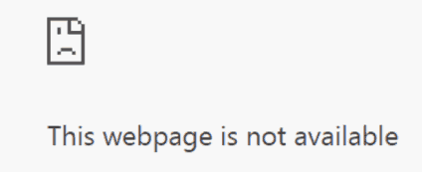

R: Essa pagina da web não esta disponivel

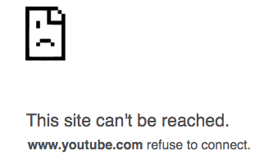
R: Esse site não pode ser acessado

Congratulations!
Parabéns por mais uma atividade feita!

